Lab 1  
Digital   
  
In this lab, we’ll be using a RBBB (Really Basic Bread Board) from ModernDevice.Com.  
It’s about a 1/3rd the price of a standard arduino, very compact, and easy to use on a bread board.

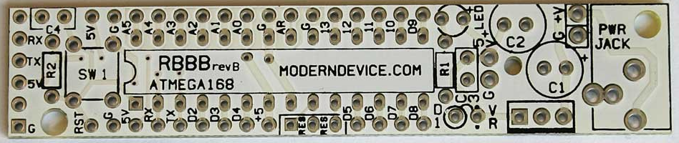

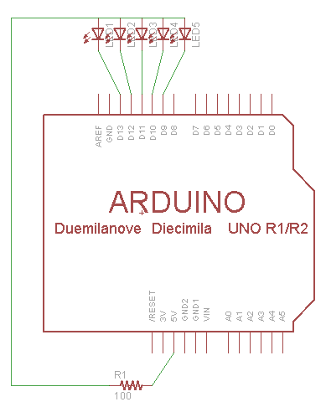In this example, five LEDs are connected to the positive rail, and pins 9, 10, 11, 12, and 13.   
A 100ohm resistor connects 5v to the positive rail.  
Always use a resistor to limit current to LEDs.  
Notice that because of planning and the RBBB design, we won’t need any more jumpers.  
  
Start a new sketch and code the following:

int led= 9;  
  
void setup() {  
 for (led=9; led<14; led++) {  
 pinMode(led,OUTPUT);  
 digitalWrite(led,HIGH);  
 }  
led = 9;  
}

void loop(){  
 digitalWrite(led,LOW);  
 delay(500);  
 digitalWrite(led,HIGH);  
 led++;  
 if (led>13) led=9;  
}  
  
Check board and port (it’s duemilenova)  
Upload to board.

Lab 2   
Input  
  
In this lab we’ll be using an Adafruit Boarduino, 3 switches, and 3 LEDs.   
Switches are connected to 2, 3, and 4 and to GND.  
LEDs are connected to 11, 12, 13 and to VCC through a 100 ohm current limiting resistor.  
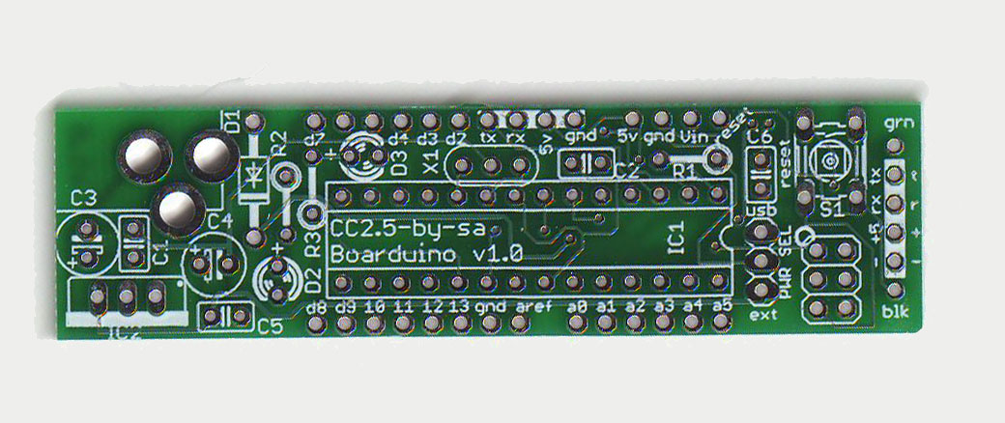

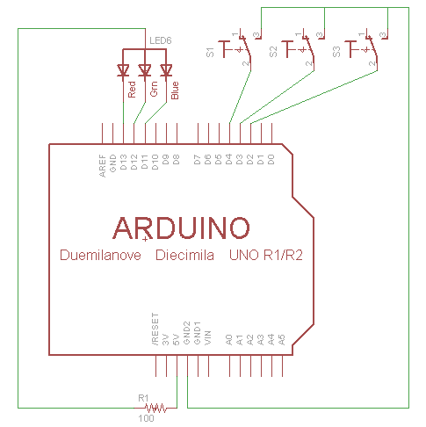When the switch is thrown to the right, it will register 0. To the Left, 1.  
We read the switches and send the value to the LED.  
  
Note the LED is in no way connected to the switches.  
  
void setup() {  
for (int i=2;i<5;i++) {  
 pinMode(i,INPUT_PULLUP);  
 pinMode(i+9,HIGH);  
 }  
}

void loop(){  
for (int i=2;i<5;i++)   
 digitalWrite(i+9,digitalRead(i));  
}

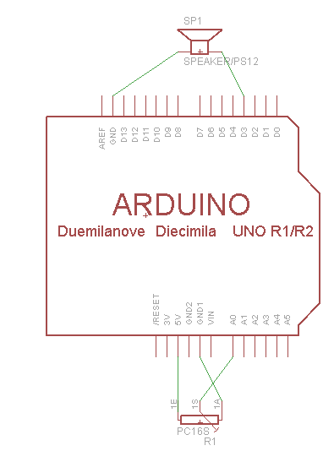Lab 3  
Analog  
  
In this lab we use a duemilenova, a 10k potentiometer, and a piezo electric speaker.  
Pizeo is connected to pin D3 and Ground.  
  
The Potentiometer is connected to V5, Pin A0, and Grnd.  
A0 will receive values from 0-255 by turning the potentiometer.  
This will actuate the speaker at a corresponding frequency.  
Turning to the left should increase the pitch, while right should reduce.  
  
void setup() {  
}

void loop(){  
int analogValue = analogRead(A0);  
int toneValue = map(analogValue,0,255,100,1000);  
tone(3,toneValue);  
}

Lab 4  
Web

This shield was originally purchased from Adafruit.Com. This is a generic shield that allows the use of either a Wiznet module or XPort module. The unit with the red module is the Wiznet. In this configuration the Ethernet shield behaves like the Arduino Ethernet Shield.  
  
Plug the Ethernet shield into an Arduino.   
Connect the Ethernet cable to shield and computer.   
Attach a jumper from GND to A0.  
This should set the value of A0 to 0.

Arduino  
192.168.1.2

At the computer, set the IP V4 address to static 192.168.1.1.   
  
Load the Ethernet: WebServer example.   
Set the IPAddress to 192.168.1.2.   
Check board and port.  
Upload to board.  
  
Open a web browser and navigate to 192.168.1.2.  
Observe:  
analog input 0 is 0  
analog input 1 is 91  
analog input 2 is 150  
analog input 3 is 213  
analog input 4 is 248  
analog input 5 is 259  
  
The web page is automatically refreshing,  
And we are basically reading random analog noise on A1-A5.  
  
Move the jumper from A0 to A1.  
Observe:  
analog input 0 is 268  
analog input 1 is 0  
analog input 2 is 93  
analog input 3 is 178  
analog input 4 is 237  
analog input 5 is 275

Ethernet

PC

A0 is now floating, and A1 is grounded.

Lab 5  
Audio  
  
In this example we use the WaveShield from Adafruit and a duemilenova.  
The WaveShield will play back audio files stored on SD card.  
This SD card contains the audio files for 0-9, and Decimal Point.  
The system will speak any digits we request.  
  
Load the WaveHC PiSpeak example.  
Shorten the value of pi to 3.14159  
Check board, port, and upload the sample.  
  
Run the example, it will repeat after speaking the digits.  
Modify the sample to speak 8675309.  
Upload again.

Arduino

SD  
CARD

SPK

WaveShield

Lab 6  
Move  
  
In this example, we will use the Adafruit Motor Shield.  
This shield greatly simplifies working with motors of various types.  
We’ll be swinging a servo motor through 180 degrees.  
  
File | Examples | Servo | Sweep  
The example works by sweeping the servo between 0 and 180 degrees,  
Then 180 back to 0 degrees.   
  
Please note that these servo motors are limited to about 180 degrees of movement.  
  
The Motor Shield can also be used for stepper motors or standard DC motors.  
Separate power is required when using larger motors,  
And the motor shield can distribute that power correctly.

Arduino

Motor

MotorShield

RESET  
  
To reset from the lab.  
File | Examples | Basic | Blink  
Upload